Revision 3: Automated systems, AI and logic - Answer key
Y11 - Cambridge IGCSE Computer Science 0478 | Teacher copy - not for students
ANSWER KEY - TEACHER COPY Covers both the worksheet and the student booklet (same task numbers). Official marking points are cited by paper; answers to exam-style questions written for this lesson are marked "suggested".
Task 1 Recall test on Revision 2 [10]
# | Answer
1 | Program counter (PC)
2 | Data bus (control bus is also two-way)
3 | More frequently used data/instructions can be accessed faster than from RAM // improves performance
4 | Assembler
5 | Compiler translates the whole program at once (interpreter one line at a time) // compiler produces an executable file // interpreter stops at the first error
6 | Domain name server/system
7 | In memory (RAM)
8 | 128
9 | The manufacturer
10 | Proxy server // firewall // anti-malware
Task 2 Automated systems and robots [18]
2A 0478/11 May/June 2023 Q9
Mark | Marking point
1 | (a) Any two: it has a mechanical structure/framework; it has electrical components (by example)
1 | (b) Any two: employees do not need to lift heavy furniture; employees are protected from dangerous tasks; employees can use their skills in other tasks; employees do not need to do repetitive/mundane tasks
1 | (c) Any one: expensive to install/purchase/set up; high ongoing/maintenance costs; may deskill the workforce; if they malfunction, production may stop

2B 0478/11 May/June 2025 Q8
Mark | Marking point
1 | (a) Any one: it has electrical components; it is programmable; it can move
1 | (b) Any one: permanent instructions/software programmed into/stored in ROM; instructions that allow hardware to be controlled; provides the operating system with a platform to run on
1 | (c) Any two, e.g.: user input; encountering an obstacle; emergency stop; hardware error; software error; battery low; component overheating; two processes accessing the same location
1 | (d) Any two: workers do not need to lift heavy machinery; less likely to injure themselves; do not need to be in dangerous environments; do not need to perform boring/repetitive tasks; can focus on higher expertise skills; new jobs maintaining the robots
1 | (e) Machine learning

2C suggested
Mark | Marking point
1 | (a) Max 4: the moisture sensor takes readings of the soil moisture; the data is converted from analogue to digital (ADC); the microprocessor compares the reading with a stored value/range; if the moisture is below the stored value, the microprocessor sends a signal to the actuator to open the valve; if it is at or above the value, the valve is closed // no action; the process repeats continuously
1 | (b) Any two: expensive to set up/buy; maintenance costs; may malfunction and plants could be damaged; needs a power supply; could be hacked; staff may need training

Task 3 AI and expert systems [13]
3A 0478/12 October/November 2023 Q10
Mark | Marking point
1 | (a) Any one: the ability to learn/adapt // machine learning; the collection of data and the rules for using that data; the ability to reason // problem solving // makes predictions; simulates intelligent/human behaviour; analyses patterns
1 | (b) Any six: it has an interface … used to input data/view output; it has a knowledge base; it has a rule base; it has an inference engine; applies the rule base to the knowledge base to provide output/diagnosis/result/solution/decision; decides what to ask next based on the data input

3B 0478/12 February/March 2025 Q6
Mark | Marking point
1 | (a) Any three: collection of data; rules for data; ability to reason; ability to adapt
1 | (b) Any three: changes its data/rules … according to feedback/results; if a result does not give a suitable response this is recorded … next time the result is changed … to provide more accurate/relevant results in future; supervised/unsupervised learning

Task 4 Logic gates and truth tables [10]
4A 0478/23 October/November 2023 Q6(a)-(c) - one mark for the gate, one for its truth table
Mark | Marking point
1 | (a) AND: 0, 0, 0, 1
1 | (b) XOR (EOR): 0, 1, 1, 0
1 | (c) NOR: 1, 0, 0, 0

4B 0478/22 May/June 2023 Q8 [4]
A | B | C | X
0 | 0 | 0 | 0
0 | 0 | 1 | 0
0 | 1 | 0 | 0
0 | 1 | 1 | 0
1 | 0 | 0 | 0
1 | 0 | 1 | 1
1 | 1 | 0 | 0
1 | 1 | 1 | 0
4 marks for 8 correct outputs, 3 for 6-7, 2 for 4-5, 1 for 2-3. Checked by evaluating the expression for all eight rows.
Task 5 Logic circuits [23]
5A 0478/22 October/November 2024 Q9
(a) One mark for each correct gate with the correct inputs [4]. Model circuit:
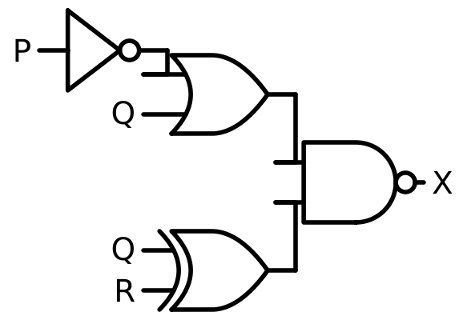
(b) 4 marks for 8 correct outputs, 3 for 6-7, 2 for 4-5, 1 for 2-3 [4]
P | Q | R | X
0 | 0 | 0 | 1
0 | 0 | 1 | 0
0 | 1 | 0 | 0
0 | 1 | 1 | 1
1 | 0 | 0 | 1
1 | 0 | 1 | 1
1 | 1 | 0 | 0
1 | 1 | 1 | 1
5B 0478/21 May/June 2025 Q7
(a) One mark for each correct gate with the correct inputs [4]:
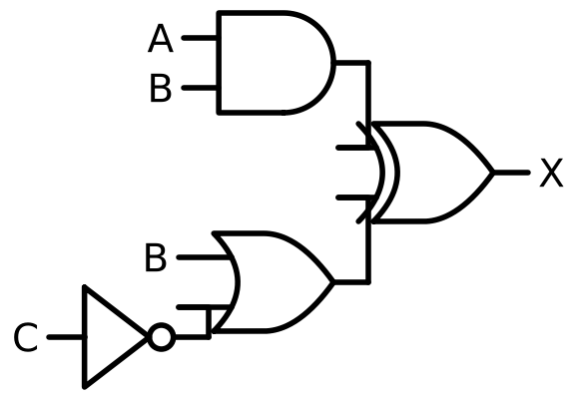
(b) 4 marks for 8 correct outputs, 3 for 6-7, 2 for 4-5, 1 for 2-3 [4]
A | B | C | X
0 | 0 | 0 | 1
0 | 0 | 1 | 0
0 | 1 | 0 | 1
0 | 1 | 1 | 1
1 | 0 | 0 | 1
1 | 0 | 1 | 0
1 | 1 | 0 | 0
1 | 1 | 1 | 0
5C 0478/22 May/June 2024 Q8
5C(a) [3]
Mark | Marking point
1 | (A AND B) // A AND B (1 mark)
1 | … AND NOT C (1 mark)
1 | Complete: X = (A AND B) AND NOT C (1 mark)

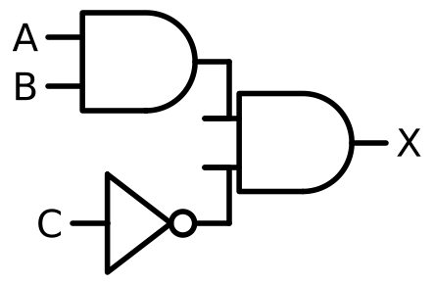
(b) 4 marks for 8 correct outputs, 3 for 6-7, 2 for 4-5, 1 for 2-3 [4]
A | B | C | X
0 | 0 | 0 | 0
0 | 0 | 1 | 0
0 | 1 | 0 | 0
0 | 1 | 1 | 0
1 | 0 | 0 | 0
1 | 0 | 1 | 0
1 | 1 | 0 | 1
1 | 1 | 1 | 0
Task 6 Extension [13]
6A 0478/23 October/November 2023 Q6(d)
One mark for each correct gate with the correct inputs [5] (three NOT gates and two OR gates):
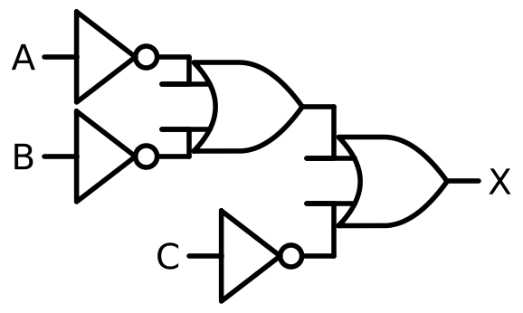
6B Exam-style (suggested)
(a) One mark for each correct gate with the correct inputs [4]: NOR(A, B); NOT C; XOR(B, NOT C); OR of the two results.
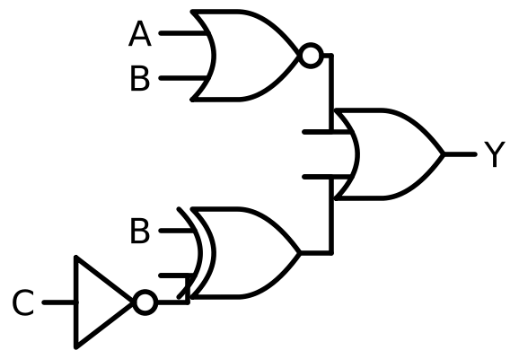
(b) 4 marks for 8 correct outputs, 3 for 6-7, 2 for 4-5, 1 for 2-3 [4]
A | B | C | Y
0 | 0 | 0 | 1
0 | 0 | 1 | 1
0 | 1 | 0 | 0
0 | 1 | 1 | 1
1 | 0 | 0 | 1
1 | 0 | 1 | 0
1 | 1 | 0 | 0
1 | 1 | 1 | 1
All truth tables were checked by evaluating each expression for every row; they agree with the published mark schemes. Model circuits were drawn from the expressions with the schemdraw library; any correct arrangement of the same gates earns the marks.

